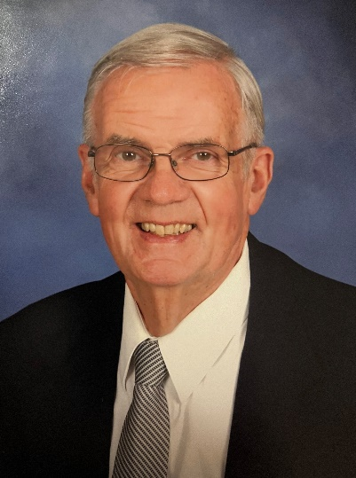
EDUCATION
BS, Civil Engineering, University of Massachusetts, 1966
MS, Management, Hartford Graduate Center, 1988

PROFESSIONAL REGISTRATION/CERTIFICATION
Professional Engineer/CT (#8416)

EXPERIENCE SUMMARY
Mr. Alford has over 35 years’ experience supervising the construction engineering of numerous projects of varying size and complexity from $100,000 to over $100 million in value, He is experienced in all aspects of construction engineering including environmental issues, maintenance and protection of traffic, contract administration and claims resolution. Mr. Alford has also had extensive interaction with governmental agencies at the federal, state, and municipal levels.

SELECTED PROJECT EXPERIENCE AS RESIDENT ENGINEER (2004 – PRESENT)
I-84 Safety & Operational Improvements, CTDOT, West Hartford, CT – Provided Resident Engineer services to CTDOT on this $65 million highway and bridge project. The project includes three new bridges along I-84 Eastbound and Westbound, the addition of auxiliary lanes, noise barrier walls, concrete barrier curb, pavement cross slope correction and drainage improvements on I-84 between Exits 39A and 43. Leon was responsible for overseeing all field inspectors, running project meetings, negotiating change orders, and ensuring overall quality.

State Project No. 0431-006 – Construction Engineering and Inspection of Waterbury Bus Maintenance Facility – ($85 million) Served as initial Resident Engineer on this new, approximately 276,000 SF building, plus associated sitework The new facility located on a parcel of property purchased by the Department in the Town of Watertown, adjacent to Frost Bridge Road (SR-262) and the Naugatuck River was built to replace the current storage and maintenance facility, located in leased space in a former foundry in the Waterville area of Waterbury.

The new facility accommodates the storage and maintenance of a mixed fleet of 98 vehicles, including 40’ and 35’ buses, plus smaller, 28’ paratransit body-on-chassis (BOC) vehicles. The new facility includes interior parking for the entire fleet, a service lane with an automatic bus wash, indoor fueling and farebox retrieval, a vehicle maintenance area with lifts and component repair areas, an administrative office area and employee welfare facilities for the drivers and maintainers.

State Project No. 0088-0177 – Construction Engineering and Inspection of CTfastrak Contract 1 – ($28 million) Served as Resident Engineer on this major project consisting of constructing 0.51 miles of Busway from Main Street to Stanley Street in New Britain. Contract 1 includes construction of a portion of the Busway, beginning at Main Street (STA. 9+60) and running northerly to an end point just south of Stanley Street in New Britian (STA. 36+25). Contract 1 also includes the construction of the Downtown New Britain Station, the demolition of the existing railroad bridge over Route 9, a new Busway bridge over Route 9, five retaining walls, and reconstruction of the Route 72 eastbound off-ramp and Route 9 southbound on-ramp at Route 71 (Truman Overpass). Additional features include constructing a multi-use trail adjacent to the Busway.

Construction Engineering and inspection of I-191 Resurfacing, Hartford to Windsor, CTDOT (18 million) – Served as Resident Engineer for resurfacing and safety improvements of 5.8 miles of 1-91 including 27 bridges.

US Route 44 Safety & Operational Improvements, Avon, CT, CTDOT ($18 million) – Served as Resident Engineer responsible for inspection on contractor’s work for the widening and reconstruction of Route 44 for a total length of approximately 1.4 miles and construction of planted median.

Reconstruction of Huntington Road, Stratford CT, CTDOT ($4.2 million) – Served as QA/QC Manager for this project which involves a full depth reconstruction of 2km of roadway. The roadway, which is currently less than 7 meters in some areas, will be outfitted with new safety features. Project elements include: two box culverts, a segmental retaining wall, new guiderail, and utility relocation.

Jenkintown Substation Project, Jenkintown, PA SEPTA ($8 million) – Served as Constructability Reviewer for the design and construction of a modern traction power substation to replace the existing Jenkintown outdoor substation. The work consists of engineering design and the preparation of drawings and specifications for all electrical, mechanical, civil, structural, architectural, environmental, safety, community relations and general construction work activities. Responsible for performing constructability review for all civil, structural, and architectural design.

I-84 Platform Illumination, Hartford, CT, CTDOT ($3.4 million) – Served as QA/QC Manager for the replacement of the existing illumination system located at the I-84 platform underpass between Main Street and Trumbull Street in Hartford, CT with a new updated system. Work includes inspection of contractor’s work, requisitions, tracking of project costs, and schedule, recording of project activities in accordance with CTDOT requirements.

CT Department of Transportation, (1985-2003) – District Engineer, directed all operations at CTDOT District 1 covering North Central CT including the greater Hartford area. Mr. Alford served as CTDOT’s liaison with the CT Construction Industries Association Constructability Review Task Force. Mr. Alford successfully managed a staff of over 200 full-time state employees, augmented by a staff of 200 consulting engineers and a total construction work value of over one billion dollars.

- I-84/I-91 Interchange in Hartford ($120 million)
- Construction of the new Charter Oak Bridge including east and west approaches ($200 million)
- Reconstruction of Founders Bridge and Adrian’s Landing ($190 million)
- Six projects involving the reconstruction of I-91 from downtown Hartford to the Massachusetts state line including the I-291 interchange in Windsor, the Route 20 interchange, and the reconstruction of the Dexter Coffin Bridge over the CT River ($360 million)
- Construction of the Central CT Expressway from Farmington to Middletown ($75 million)
- Rehabilitation of over 100 bridges
- Numerous Building and facility projects including Terminal A at Bradley International Airport
- Rest areas along I-91 and I-84, DOT garages and maintenance facilities
- Numerous intersection improvement projects, traffic signal installation, highway signs including variable massage, commuter parking lots, traffic monitoring TV cameras along I-91 and I-84, improvements to municipal roads and bridges.
- Construction of I-291 from Windsor to Manchester including I-84 interchange and widening of the Bissel Bridge over the CT River ($110 million)

CT – Department of Transportation (1978 – 1985) Engineer of Soils and Foundations – Served as the Department’s Chief Geotechnical Engineer directing a staff of engineers geologists and consultant engineers. Projects included:

- Deep foundation Charter Oak Bridge over CT River Hartford to East Hartford.
- I-84 – I-91 Interchange Hartford
- Central CT Expressway
- Widening of Founders Bridge foundations over CT River.
- I-291 over CT River Windsor – South Windsor

